Lab Assignment -2

1.

Question:

R Project

Prepare a dataset and perform k-means clustering.

Description:

Used a sample dataset AML.csv and performed **k-means** clustering in R by using R default k-means function. And plotted a graph of original data set comparing to cluster that has been created.

Screenshots:

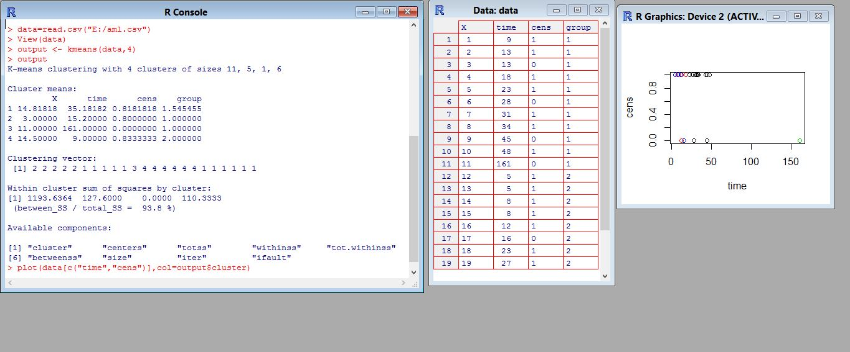

2.

Question:

RoboMe and Watch App

Create a RoboMe and Watch App that uses weather or any API of choice.

Description:

Used Open Weather API to get the weather of the city using the unique ID provided by openweather.com.

Used HTTP web services to fetch the data from OpenWeather.com

“[http://api.openweathermap.org/data/2.5/weather?id=**4273857**&units=**metric**&appid=**a149d0dfbedce700edce4a82cccb6c32**](http://api.openweathermap.org/data/2.5/weather?id=4664788&units=metric&appid=a149d0dfbedce700edce4a82cccb6c32)”

ID – City ID -

Units – Metric [will return result in Celsius]

AppID – Unique ID Created by open Weather to access web services.

